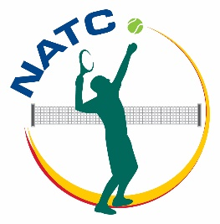**Nepalese Australians Tennis Club (NATC) Brisbane Inc.**

Membership Application Form

**Applicant Personal Details**

Family Name ______________________________First Name: _____________________

Additional member of family included in the application

1. Name _____________________________________Relation______________
2. Name _____________________________________Relation______________
3. Name _____________________________________Relation______________

Residential Address: Unit no: _______ Street No: _________________________

Street Name: ______________________________________________________________

Suburb: ______________________________ State: __________________________

Phone: _________________________ Email: ________________________________

**Membership Type Applied for**

**□** General **□**Active Player **□**Junior Player **□**Life Member

**Evidence of Membership Fee Paid:**

Bank Transfer Receipt Number: _________________ Date Paid: _____________

Applicant Signature: ____________________________ Date: _________________

***Office Use Only***

Application received date:____________________ Reviewed by_________________

Approval Status: **□**Approved **□**Rejected date:__________________

If rejected, reason for rejection: _______________________________________

Outcome of the application must be informed to the applicant.

Date Informed __________________ Method: **□**Email **□**Postal letter **□**Verbal/Phone

**Contact us:**

Nepalese Australians Tennis Club (NATC)

Address:

Email: [NATCbne@gmail.com](mailto:NATCbne@gmail.com)

Phone: 0401 903 304

**Please make direct transfer of membership fee to**

Nepalese Australians Tennis Club, Brisbane Inc.

Commonwealth Bank

BSB xxx-xxx Account: xxx xxx